**Software Architecture Assessment for Sustainability: A Case Study**

Summary**：**

In the review of SA assessment methods, the team observed a lack of SA assessment methods or their application for sustainability. So that they developed an SA evaluation blueprint tailored for sustainability assessment. They aim to answer the research question, “How to guide software architects in assessing SA for sustainability?”

They use the case of Canvas integration as a subject for SA assessment to support the educational institute for its new sustainability reporting requirements. This study evaluates design decisions based on prioritized evaluation criteria, using a mix of experience-based and quantitative approaches.

Key technique: blueprint developed by the team as below.

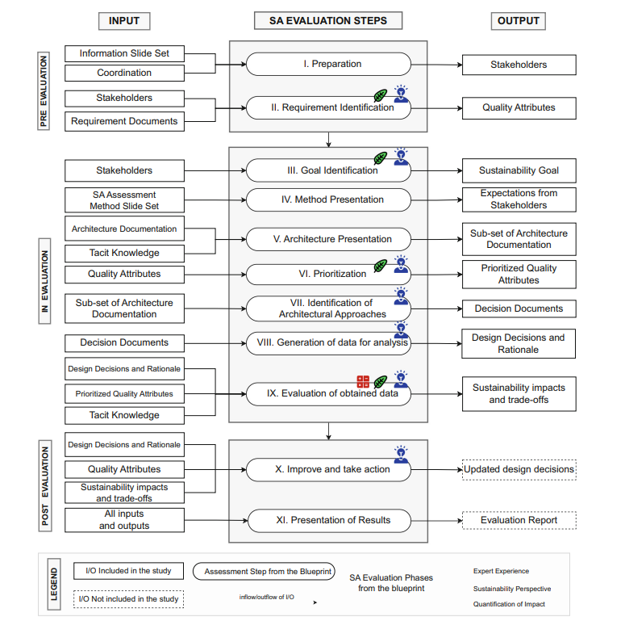

They utilized the tacit knowledge of the experts to explore the documentation and used their expertise to extract architecture design decisions. Then in generating Data step, they extracted design decisions from the identified architecture approaches which acted as data for evaluation. The nine extracted decisions were validated by the experts as being correct and having architectural implications. We gathered feedback from the experts for each step of data generation and analysis going forward. The extracted design decisions were used as input for evaluation step. They used a combination of two techniques, (i) Experience-based technique – by using feedback from the experts for analyzing alternatives and trade-offs, and (ii) Quantification-based technique – by using elements of open source SAF Toolkit and Sustainability Impact Score (SIS) to identify sustainability impact.

The study helps the evaluators visualize the interdependencies for such trade-offs for informed decision-making. The approach used SIS to streamlines the assessment process by providing a consolidated evaluation of sustainability dimensions and highlighting trade-offs that may not be immediately evident, which support evaluators in the decision-making process.

This approach aids decision-making by quantifying the sustainability support across dimensions, which enabling evaluators to consider alternative design options for better trade-offs. But this approach now only focus on the specific educational field, maybe the evaluation is not suitable for all SA case.

Improve**：**

In the assessment, they do not regard the sustainability dimensions as a prior factor, which may affect making an informed decision. So I think maybe they should first make the model then re-prioritize the model factors, then the results can reflect the impact of four dimensions more accurately.

What’ s more, the dependency matrix used to see the inter-dimension impact of QAs only has three values. But a same impact (like both positive in Economic) may has different strengths, set more values of impact can make some differences of SIS more apparent. Therefore we can know which of the dimension is favored in the case, and get a more real SA assessment.